**Experiment 3.1**

**Student Name:   Gaurav Kumar                                UID: 22MCC20177**

**Branch:   CC-DevOps                                                     Section/Group:- 1/B**

**Semester:   One                                                               Date of Performance: 13/12/2022**

**Subject Name:- Design & Analysis of Algorithms Lab                   Subject Code: 22CAP-646**

1. **Task to be done:**

a. Obtain the Topological ordering of vertices in a given digraph.

b. Compute the transitive closure of a given directed graph using Warshall's algorithm.

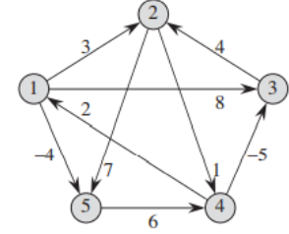

1. **Steps for experiment/practical: copy and paste your code here/screenshots**
2. #include <bits/stdc++.h>

using namespace std;

#define V 5

#define INF 99999

void printSolution(int dist[][V]);

void floydWarshall(int dist[][V])

{

    int i, j, k;

    for (k = 0; k < V; k++)

    {

        for (i = 0; i < V; i++)

        {

            for (j = 0; j < V; j++)

            {

                if (dist[i][j] > (dist[i][k] + dist[k][j]) && (dist[k][j] != INF && dist[i][k] != INF))

                    dist[i][j] = dist[i][k] + dist[k][j];

            }

        }

    }

    printSolution(dist);

}

void printSolution(int dist[][V])

{

    cout << "The following matrix shows the shortest distances between every pair of vertices \n";

    for (int i = 0; i < V; i++)

    {

        for (int j = 0; j < V; j++)

        {

            if (dist[i][j] == INF)

                cout << "INF"

                     << " ";

            else

                cout << dist[i][j] << " ";

        }

        cout << endl;

    }

}

int main()

{

    int graph[V][V] = {

        {0, 3, 8, INF, -4},

        {INF, 0, INF, 1, 7},

        {INF, 4, 0, INF, INF},

        {2, INF, -5, 0, INF},

        {INF, INF, INF, 6, 0}};

    floydWarshall(graph);

    return 0;

}

1. **Output (screenshots)**

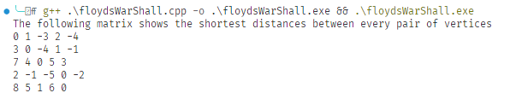

**Evaluation Grid:**

|  |  |  |  |
| --- | --- | --- | --- |
| Sr. No. | Parameters | Marks Obtained | Maximum Marks |
| 1. | Demonstration and Performance  (Quiz) |  | 22 |
| 2. | Worksheet |  | 8 |